# Team Project: Circus restaurant

We are now going to make a real-world project. We will take everything we have learned and put into practice.



**Background:**

You have a customer opening a new restaurant in the middle of Stockholm city. He has a new concept in mind...

He wants people to eat and watch a circus show every Friday or Saturday. The restaurant owner is going to get a famous circus person to the restaurant in every show every week.

**Requirements (max 250p):**

The customer wants your help building a website for his new Circus restaurant.

1. The website should contain an order system for customers to order food when they are in the restaurant. Every table would have a tablet in each table. As a customer you should be able to see the menu, order and choose ingredients. **(100p)**
2. The website should also contain a booking system for the circus show every Friday or Saturday **(50p)**
3. The website should contain information about the restaurant like e.g. phone number, address, map and contact... **(50p)**
4. The landing page/home page should contain an ad for the shows to come. A user should be able to click on the ads and go directly to the e.g. booking system. **(50p)**

**Documentation (100p):**

The customer needs a documentation on the whole project. From start to end.

He wants to know how you did it and why. So make sure you write the documentation along with the project.

If you e.g. tried something and failed? Then you have to explain what happened and so on…

You basically need to write everything you do. What tools did use? What programming language. And you also need to explain the “why’s”.

**SCRUM (100p):**

Every team should work within the requirements of scrum. Start by creating a Scrum board on [Trello](https://trello.com/) and fill your backlog. And remember try to split up the problem. This needs to be done in a team meeting.

In the first meeting you should fill the backlog. You can also have meetings along the way for example if something needs to be talked about.

**You also need to have a daily stand-up everyday at 09:15. A daily stand-up shouldn’t be more then 10-15 min.**

Remember to also review the whole project at the end together.

**UI/UX (150p)**

**research:**

Ask you friends, family, neighbors, or maybe people on the street on what they think about the circus restaurant idea?

Make sure you ask the right question:

**Example question on a survey:**

Here is just an example of the questions you can use:

NOTE: You need to come up with additional questions.

Gender?

How old?

How would you like to order the food?

What color is excepted in the website?

What do you think about the concept?

Would you like to eat and watch a show?

Who will you bring with you?

What kind of food do you like?

Etc.

**Analysis:**

Now when you are done with the research you need to analyze the answers you and your team have got.

You can use tools like Excel to make a e.g. bar chart

EXAMPLE:

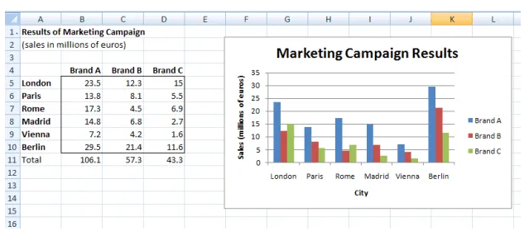

**UX design:**

Now you need to make a so called “mockup” with a wireframe program. You can either paint it by hand or use tools on the internet:

And when you and your team are happy with the results you should start coding the website.

Here are some examples of wireframes programs.

You could probably find more (Free) wireframe programs on the web.

Examples:

<https://balsamiq.com/wireframes/desktop/>

<https://www.mockflow.com/>

<https://www.hotgloo.com/>

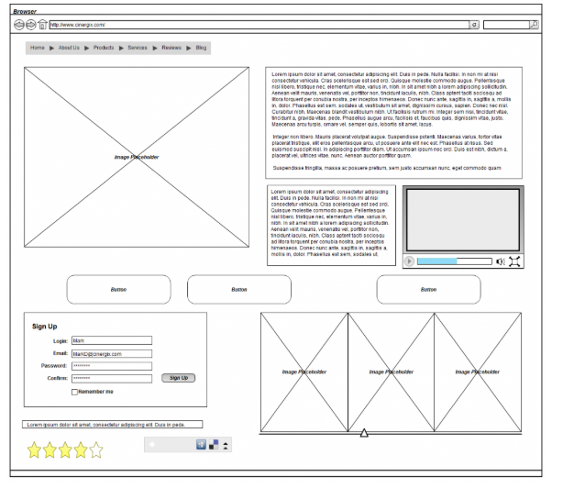

**Presentation (100p):**

You need to make a professional presentation using e.g. PowerPoint when you and your team are done with project.

**The presentation should cover:**

* Presentation on what the project is.
* Presentation on who did what, and what roles you had in the team.
* How you did the project. What tools you have used… and why?
* How does it work? (Demonstration)
* Show code and explain.

**SUBMIT:**

What Haithem (teacher) want in the zip file:

1. Project Documentation
2. Research, Analysis, pictures/ design.
3. Scrum board
4. Code and website

Submit your zip file and the team project to [Haithem@lexicon.se](mailto:Haithem@lexicon.se) when you are done.

**Scores:**

* < 400p – (D) Fail!
* 400p - 550p = (C) Pass!
* 550p - 650p = (B) Great!
* 700p = (A) Excellent!

Happy coding! =)